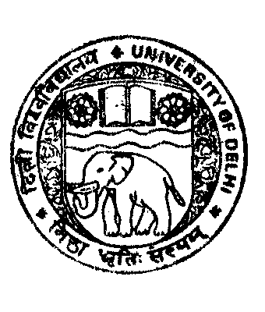
ADMISSION NOTICE-2010

Applications are invited for Admission to Bachelor of Homoeopathic Medicine and Surgery (BHMS) 5½ years Course-2010 at Nehru Homoeopathic Medical College, New Delhi. The Bulletin of Information may be obtained from the office of the Faculty of Homoeopathic Medicines, 6th floor, V.P. Chest Institute Building, University of Delhi, Delhi-110 007, only against a Bank Draft / Banker’s Cheque drawn on any Nationalised Bank in favour of Registrar, University of Delhi payable at Delhi in the following manner:-

- By Hand for Rs. 500/- (Rs. Five Hundred only) for General/OBC Categories & Rs. 350/- (Rs. Three Hundred & Fifty only) for SC/ST/PH Categories between 10:00 A.M. to 03:00 P.M. on all working days from 01st June, 2010 to 22nd June, 2010.

- By Post for Rs. 550/- (Rs. Five Hundred and Fifty only) for General/OBC Categories & Rs. 400/- (Rs. Four Hundred only) for SC/ST/PH Categories along with a self addressed envelope of 10" X 8" upto 15th June, 2010.

Note:- SC/ST/PH Candidates are requested to bring/ send a copy of the Caste Certificate/ PH Certificate for obtaining Bulletin of Information.

Money in case will not be accepted in any case for supply for Bulletin of Information.

1. Eligibility Conditons

(A) Age: He/She must have attained or will attaine the age of Seventeen (17) years as on 31st December 2010.

(B) FOR 85% DELHI QUOTA SEATS: BHMS 1st Prof. Admission

The candidates must have passed XIIth Class (12 years course) or any other equivalent Examination recognised by the University of Delhi with 60% or more marks in the aggregate of three subjects i.e. Physics, Chemistry, Biology and has also passed English as one of the subject from the recognised school conducting regular classes situated within the National Capital Territory of Delhi (except Private, Patrachar Vidhyalaya and Open School). While deciding the merit the marks obtained in English will not be taken into consideration.

(C) FOR 15% All QUOTA SEATS:

The candidates from all over India who have passed XIIth Class (12 years course) or any other equivalent Examination recognised by the University of Delhi with 60% or more marks in the aggregate of three subjects i.e. Physics, Chemistry, Biology and has also passed English as one of the subject from the recognised school conducting regular classes (except Private, Patrachar Vidhyalaya and Open School). While deciding the merit the marks obtained in English will not be taken into consideration.

Application Form may also be downloaded from our websites www.du.ac.in or www.fmsc.ac.in and submit the same, duly filled in and complete in all respects with requisite Demand Draft, to the office of the Deputy Registrar, Faculty of Medical Sciences, 6th Floor, V.P. Chest Institute Building, University of Delhi, Delhi- 110007 on or before 22nd June, 2010 upto 03.00 P.M.

The Application Forms can also be obtained, by hand against Demand Draft from the office of the Principal, Nehru Homoeopathic Medical College, B -Block, Defence Colony, New Delhi.

The last date for submission of Application Form is 22.06.2010

For details please see our websites www.du.ac.in or www.fmsc.ac.in

The Faculty of Homoeopathic Medicines will not be responsible for any delay in the postal transit.

REGISTRAR

UNIVERSITY OF DELHI
Faculty of Homoeopathic Medicines

Faculty of Homoeopathic Medicines

Last Date: 22.06.2010

